The 9th International Conference on Sustainable Economic Development
and Business Management:

SEDBM2026

12th – 14th November 2025 AOF, Hanoi| Vietnam
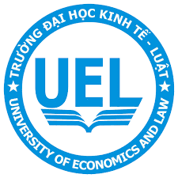 | 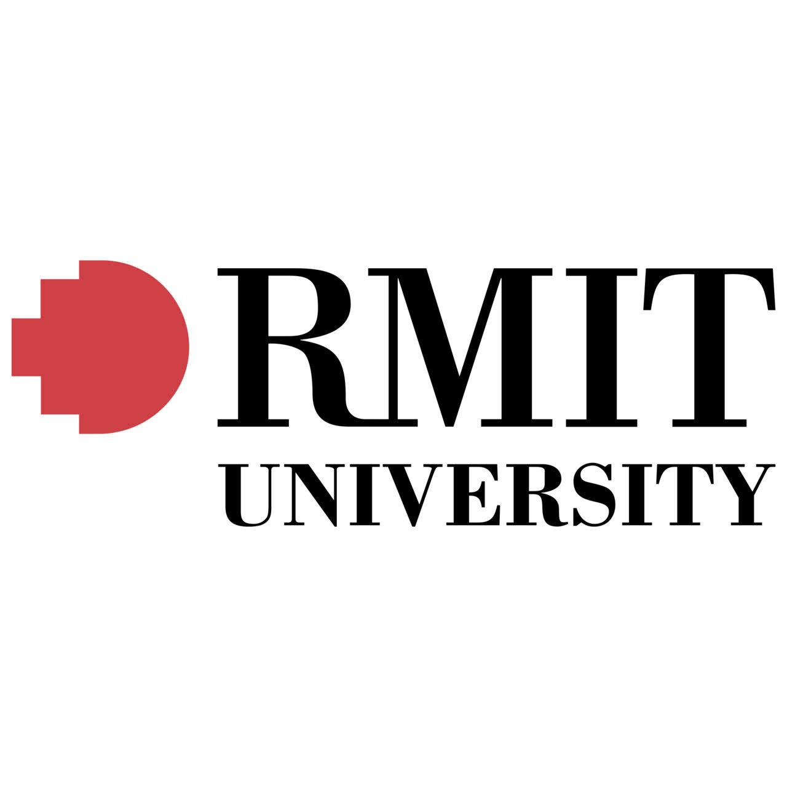 | 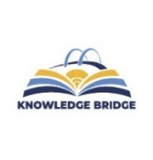 | 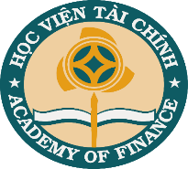 |  | 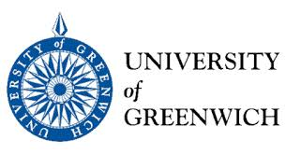 | 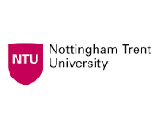 | 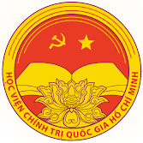
CALL FOR PAPER
SEDBM - 2026 solicits high quality, unpublished and authentic contributions that discusses innovative research ideas and innovation and research challenges.
The major focus of our conference are:
• To share a collaborative knowledge platform among researchers from diversified areas of sustainable economic development, business management, finance and accounting from different corners of the world
• To promote a partnership among academia and industry
• To publicize innovative research ideas and recent trends in sustainable economic development, business management, finance and accounting research
• To provide a wide platform to the budding researchers for sharing their ideas in front of eminent speakers from highly renowned organizations
Some of our popular areas, not limited to, but as follows are:
- SUSTAINABLE ECONOMIC DEVELOPMENT
- ACCOUNTING AND AUDIT
- FINANCIAL MANAGEMENT
- HUMAN RESOURCE MANAGEMENT
- MARKETING MANAGEMENT
Submission Guideline
Authors are invited to submit their manuscripts in English before the deadline via CMT Platform and must comply with the Springer format (Manuscripts should be sent via email: aof_sedbm@hvtc.edu.vn for backup purpose)
Publication |  |  |  | Contact us
All peer-reviewed papers presented at SEDBM 2026 will be revised and extended versions evaluated by a qualified commitee. Selected papers will be included in theo conference proceeding, to be published by a domestic or international publisher. |  |  |  | Email: aof_sedbm@hvtc.edu.vn  Nguyen Minh Thanh, The Academy of Finance  Tel: +084 912 691 315  Website:  QR code  Link to website
Important Dates

Full-text Paper Submission: Deadline August 20th, 2026  Notification of Acceptance/Rejection September 20th, 2026 |  |  |  | Registration: October 20th, 2026  Conference Dates: November 12th-14th, 2026

